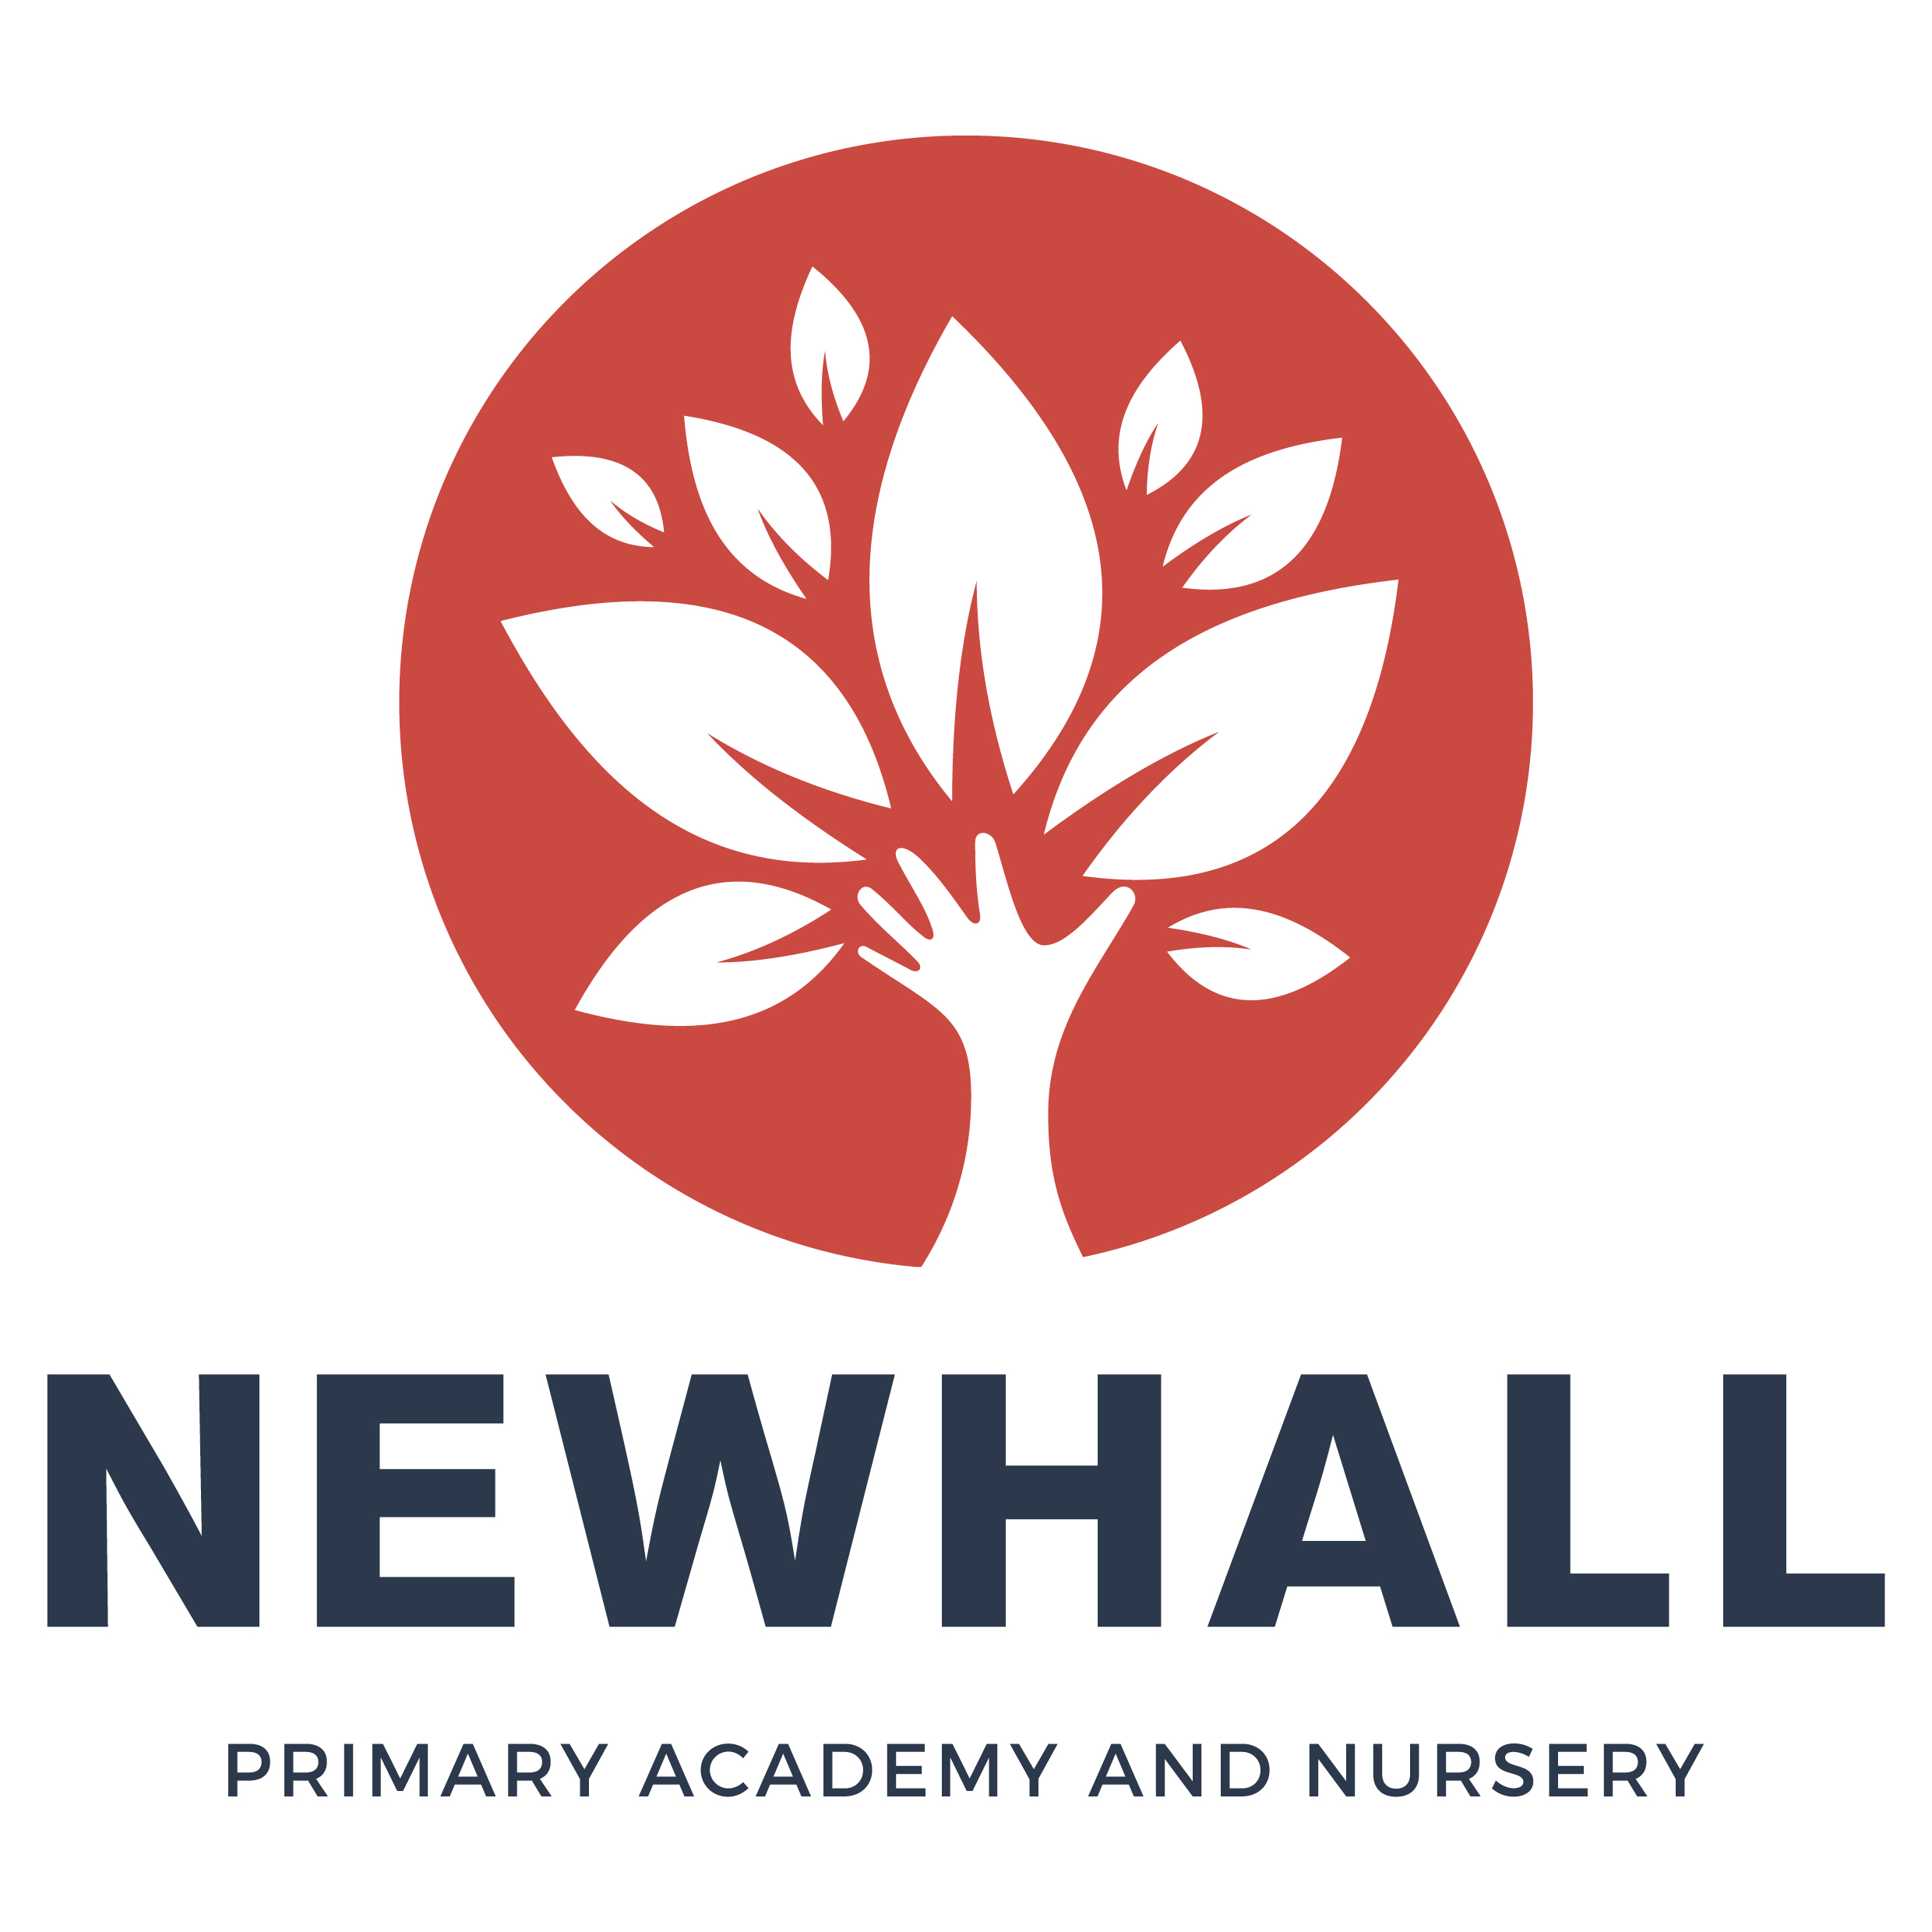

“Aiming high; Reaching higher”

Newhall Nursery Prospectus
Linked Policies:
E-Safety Policy
ICT Policy
Safeguarding Policy
Linked Policies:
E-Safety Policy
ICT Policy
Safeguarding Policy

Honesty Respect Responsibility Resilience Aspiration Reflection

A message from the Headteacher
Newhall is a brand-new, state of the art academy and nursery on the Newhall development in Harlow. The Primary Academy will initially have an intake of 60 children. It will then grow year-on-year until it reaches full capacity of 420. The Nursery will have capacity for 56 children, with a 2- 3 year room and a pre-school room, but with plans to also open up a baby unit in 2019 for children aged 6 months to rising 2 years,
At Newhall we aim to provide an exciting and challenging curriculum which is designed to engage and motivate all children. We want our children to become resilient, independent thinkers with a thirst for learning. Whilst we strive for high academic standards, we are also totally committed to developing the creative, physical, emotional and social aspects of all of our children’s lives.

We offer a safe, nurturing and stimulating learning environment, which enables us to ensure our children are supported, challenged, inspired and motivated through a breadth of learning experiences and opportunities. We committed to safeguarding and promote the welfare of all children. We expect all staff to share this commitment.

We aim to be at the heart of this new community and will therefore endeavor to foster strong relationships between children, staff, parents, governors and the wider community of Harlow. We welcome the opportunity to work with you to develop bright, ambitious, confident and inquisitive children.

Newhall is an academy where every child is respected and treated as an individual, with no limits placed on their learning – just opportunities to continually improve with a ‘Growth Mindset’ approach. We believe in the potential of every individual, from whatever circumstance, to achieve and enjoy their time at our nursery and school. We do not ‘label’ children or group them by perceived ‘ability’; instead, we give all children equal opportunities to challenge themselves through the range of tasks and activities presented to them – empowering children to take ownership and responsibility for their own learning.

I look forward to meeting you, and showing you what a fantastic place of learning Newhall is.

Debbie Gayler

Mission statement

Our mission statement, “Aiming high; Reaching higher”, underpins everything we do and strive to do.

Vision

Children at Newhall will feel safe, valued and develop a love of learning.

This will be achieved by:

- Always being truthful, fair and inclusive.
- Respecting, listening to, valuing and recognising the uniqueness and achievement of every member of our academy family
- Providing outstanding learning and teaching which enables all students, regardless of gender, race, background or ability, to excel academically, emotionally, physically, socially, morally, spiritually and culturally.
- Equipping children with the resilience and perseverance to become creative and independent thinkers and to become learners for life within an ever-changing world.
- Raising the aspirations of everyone within our academy community so everyone strives for personal excellence in everything they do
- Developing learning activities which stimulate positive models of enquiry, reflection, challenge and innovation.

Our Vision is underpinned by our six Core Values:

- Honesty
- Respect
- Responsibility
- Resilience
- Aspiration
- Reflection

Opening Hours
The Nursery is open from 7:30am to 6pm.
We open 5 days a week all year round, excluding Bank Holidays, two Professional Development Days (One Term Notice given) and a week at Christmas.
We will work in partnership to support your child to settle, which may take time initially, as we want your child to feel happy, safe and secure.

Admissions
To initially register your child and cover administration costs a £50 Non-Refundable fee is required. This will be taken off your fees at the end of the first month. Please be aware, should you not take up a place once confirmation of a start date has been given by the Nursery, you then forfeit the deposit. This also applies to the reduction of hours. Payment must be made monthly in advance.
All invoices are emailed and password protected. The password is the first 6 letters of your child’s name all lowercase.
NEWHALL IS UNABLE TO SECURE YOUR CHILD’S PLACE UNTIL A DEPOSIT HAS BEEN RECEIVED
Please make all cheques payable to: Newhall Primary Academy and Nursery. Up until 24th August 2018, cheques and registration forms can be sent to Pemberley Academy, Hodings Road, Harlow CM20 1NW, for the attention of Newhall Nursery Manager. After 24th August 2018, please send all deposit cheques and registration forms to Newhall Primary Academy and Nursery, Roundhouse Way, Harlow CM17 9SF.
No deposit or payment is required for funded 2,3 and 4 year olds.
Places will be snapped up quickly at Newhall Nursery so we advise completing a registration form as early as possible. We will hold a waiting list.

The Curriculum in Early Years Foundation Stage (EYFS)
At Newhall we follow the Early Years Foundation Stage framework. This is a curriculum deeply rooted in the foundations of play in order to support our children to develop their social skills working harmoniously together, whilst gaining a strong foundation in English, Mathematics and creative and physical skills. It is made up of four themes which are:

A Unique Child: Every child is a unique child who is constantly learning and can be resilient, capable, confident and self-assured.

Positive Relationships: Children learn to be strong and independent through positive relationships.

Enabling environments: Children learn and develop well in enabling environments, in which their experiences respond to their individual needs and there is a strong partnership between practitioners, parents and carers.

Learning and Development: Children develop and learn in different ways. The framework covers the education and care of all children in early years provision, including children with special educational needs and disabilities.

The themes of a unique child, positive relationships and enabling environments all feed into how we teach the learning and development theme.

Learning and development theme
The Learning and development theme is split into 7 areas of learning:

- Communication and Language development involves giving children opportunities to experience a rich language environment; to develop their confidence and skills in expressing themselves; and to speak and listen in a range of situations.

- Personal, Social and Emotional Development involves helping children to develop a positive sense of themselves, and others; to form positive relationships and develop respect for others; to develop social skills and learn how to manage their feelings; to understand appropriate behaviour in groups; and to have confidence in their own abilities.

- Physical Development involves providing opportunities for young children to be active and interactive; and to develop their co-ordination, control, and movement. Children must also be helped to understand the importance of physical activity, and to make healthy choices in relation to food.

- Literacy development involves encouraging children to link sounds and letters and to begin to read and write. Children must be given access to a wide range of reading materials (books, poems, and other written materials) to ignite their interest.

- Mathematics involves providing children with opportunities to develop and improve their skills in counting, understanding and using numbers, calculating simple addition and subtraction problems; and to describe shapes, spaces, and measures.

- Understanding of the world involves guiding children to make sense of their physical world and their community through opportunities to explore, observe and find out about people, places, technology and the environment.

- Expressive arts and design involves enabling children to explore and play with a wide range of media and materials, as well as providing opportunities and encouragement for sharing their thoughts, ideas and feelings through a variety of activities in art, music, movement, dance, role-play, and design and technology.

In Early Years we follow children’s interests to offer them a stimulating and engaging curriculum. We use these interests to teach the seven areas of learning described above. Children are continually assessed through observations and focus groups and the provision supplied is a result of this assessment.

Children will have the opportunity to access the outdoors daily which will enable many learning opportunities.

At Newhall your child’s keyworker will share your child’s progress and interests and we hope to work in partnership and learn about your child at home.

Communication

It is key to support your child’s wellbeing and we will work in partnership in many different ways, including newsletters, daily feedback and review meetings. We are available if you wish to make an appointment to speak to your child’s Key Worker or the Nursery Manager

Children with Additional Needs

Newhall Nursery is keen to integrate children with special needs where it is clear that our facilities and resources can effectively meet the needs of the individual child.
Attendance
It is important that your child has regular attendance at Newhall Nursery and your child's attendance will be monitored carefully. You will be required to notify us within one hour of the start time of the session of your child’s absence and the reason for their absence. The nursery understands that from time to time it may not be possible for your child to attend nursery; however, if the attendance is irregular without any reason, you will be supported in the first instance, but if attendance does not improve your child’s place may be terminated and offered to another child.

Fees (unfunded)
6 months – 2 years – Ratio 1:3 (Up to 16 children)
Day | Early Start  7.30 – 8 | Morning (5h) 8-1 (Inc B+S) | Afternoon (5h) 1-6  (Inc T+S) | Long Day (10h)  8-6  (Inc B, L, T)
Monday | £4 | £27.50 | £27.50 | £57.50
Tuesday | £4 | £27.50 | £27.50 | £57.50
Wednesday | £4 | £27.50 | £27.50 | £57.50
Thursday | £4 | £27.50 | £27.50 | £57.50
Friday | £4 | £27.50 | £27.50 | £57.50

2-3 years – Ratio 1:4 (Up to 20 children)
Day | Early Start  7.30 – 8 | Morning (5h) 8-1  (Inc B+S) | Morning (3h) 9-12  (Inc S)  TT only | Afternoon (5h) 1-6  (Inc T+S) | Afternoon (3h) 12-3  (Inc S)  TT only | Long Day (10h)  8-6  (Inc B, L, T) | Short Day (6h)  9-3  (2S + L)TT only
Monday | £4 | £26.50 | £15.90 | £26.50 | £15.90 | £55.50 | £34.30
Tuesday | £4 | £26.50 | £15.90 | £26.50 | £15.90 | £55.50 | £34.30
Wednesday | £4 | £26.50 | £15.90 | £26.50 | £15.90 | £55.50 | £34.30
Thursday | £4 | £26.50 | £15.90 | £26.50 | £15.90 | £55.50 | £34.30
Friday | £4 | £26.50 | £15.90 | £26.50 | £15.90 | £55.50 | £34.30
3-4 years – Ratio 1:8 (Up to 20 children)
Day | Early Start  7.30 – 8 | Morning (5h) 8-1 (Inc B+S) | Morning (3h) 8.45-11.45  (Inc S)  TT Only | Afternoon (5h) 1-6  (Inc T+S) | Afternoon (3h) 12.30-3.30  (Inc S)  TT only | Long Day (10h)  8-6  (Inc B, L, T) | Short Day (6h)  9-3  TT only
Monday | £4 | £25 | £15 | £25 | £15 | £52.50 | £32.50
Tuesday | £4 | £25 | £15 | £25 | £15 | £52.50 | £32.50
Wednesday | £4 | £25 | £15 | £25 | £15 | £52.50 | £32.50
Thursday | £4 | £25 | £15 | £25 | £15 | £52.50 | £32.50
Friday | £4 | £25 | £15 | £25 | £15 | £52.50 | £32.50
Free Early Education Entitlement (FEEE) is the name given to the early education childcare parents may receive free of charge, funded by the Government. Newhall Nursery currently offers places for all three current Government schemes in operation, some of which are based on selective criteria and normally income based and therefore not open to all parents. Please see the Newhall FEEE Policy for further details or ask the Nursery Manager regarding two year funding, universal nursery education and/or 30 hour funding.

Uniform

Children in the Nursery Pre-School Class are expected to wear a distinctive red Newhall round-neck jumper, red Newhall polo shirt and black jogging bottoms, skirt, shorts, school trousers or pinafore. The jumper and polo shirt can be purchased through Create Identitee in Harlow. Wellington boots are required for outdoor play and forest schools as well as spare clothes in case of accidents.

Withdrawals
One months notice should be given to withdraw a child from Newhall Nursery or to reduce the number of sessions attended. Fees will be payable in lieu of notice. For fully funded children, one terms notice must be given.

Nursery Staff
Newhall Early Years Team comprises of a Nursery Manager, EYFS Phase Leader, 2 EYFS Teachers, a Supervisor in each area, Nursery Practitioners and Apprentices. The Staff have a variety of childcare qualifications including Foundation Degree, NNEB, and NVQ’s, all fully approved by the relevant authorities. All staff have enhanced DBS checks and we follow Safer recruitment procedures.
There will be occasions when the Nursery has students, volunteers or apprentices. Anyone supporting at Newhall Nursery will not be left unsupervised without first undergoing an enhanced DBS check.
Policies
Newhall Primary Academy and Nursery has a range of policies and all parents are required to read and agree to these policies in writing. You will also be able to find a copy of these on the Newhall website. Paper copies can be provided on request from the Nursery Office.

Meals & Snacks
A snack will be offered in the morning and afternoon. Children with allergies to specific foods or ingredients will be catered for. Milk and water is always available to the children at snack time and throughout the day. For younger children, sealed formula powder may be brought in which will be labelled and stored appropriately.
We have a fruit and vegetable week at the start of every month where new fruit and vegetables are tried and we make lots of interesting snacks – including fruit smoothies, fruit salad and soups.
Other snacks include:
- fresh / seasonal cut up fruit or vegetables
- sandwiches
- rice cakes
- bread sticks
Where a child is to remain at the Nursery during the lunch time, children will be provided with a freshly cooked meal. Menus for each week are on display in the front entrance or can be found on the Academy and Nursery website. We can also serve food at tea time for those that stay late. If you choose to send your child in with a packed lunch, then lunch boxes must be clearly marked with the child's name. Healthy options are promoted –No sweets, chocolate, sweet drinks or crisps. Packed lunch ideas are posted on the main notice board monthly.

Notifiable Diseases
Newhall Nursery holds a policy on notifiable diseases and if your child contracts any infectious illness you must tell us without delay and we will advise you as to whether or not your child can attend nursery.

First Aid
All staff hold a current Paediatric First Aid Certificate, and have received instruction specifically covering the administering of first aid to infants and children. On-going training is in place. All accidents are entered on an accident report form and will be signed by both a member of staff and counter-signed by the person collecting the child. You will be informed of any head injury or serious accident requiring medical attention.

Toileting / Nappies
Nappies, creams and wipes must be provided for your child. Any supplied by the Nursery will be charged for. A record is kept of changes. We endeavour to work together to support toilet training and according to the developmental needs of the individual child.

Medication
Full details must be given in advance with a signed and dated request if nursery is to administer any prescribed medication in the original container and labelled with the child’s details. Details required will include name of medicine, time of last dose, dosage and times required with any special instructions. Calpol will not be administered unless in an emergency with permission from parents. Written permission must be given for creams or teething gels.

When Your Child Is Unwell
If your child becomes ill or unduly distressed during nursery hours, we will endeavour to contact a parent so that arrangements can be made for early collection. In the interests of other children and staff it will be necessary to exclude any child who has been diagnosed with certain contagious illnesses and diseases. An exclusion period of 48 hours is required for antibiotics, sickness and diarrhoea. We will inform you and monitor if your child has a temperature and may need to collect your child.

Care & Positive Behaviour Management
Each and every child is treated as an individual. A key worker is allocated to each child who will closely monitor your child's progress and welfare. In cases of 'anti social' behaviour, staff endeavour to explain why such behaviour is unacceptable. The staff use only positive guidance, redirection and the setting of clear-cut boundaries that enable the child to become self-disciplined. Our aim is to encourage the children to be fair, respect property, respect others and to be responsible for their own actions and manage themselves whilst considering others.
Discipline and guidance is consistent and based on an understanding of the individual needs and development of your child and partnership working with parents/carers is important to achieve this.
Aggressive physical behaviour towards staff or a child is unacceptable. Staff will intervene immediately when a child becomes physically aggressive to protect all children and encourage more acceptable behaviour.
Newhall Nursery reserves the right to exclude any child at any time if it is considered that this is in the best interests of the children. This is wholly at the discretion of the Nursery Manager.

Collection
Children are only released to the adults listed on the consent form provided by you. Release to any other adult may occur with a written authorisation signed and dated by you, or by direct communication with the Nursery Manager. We have a password system in place for this. Identification may be requested at any time.

Health & Safety
Health and safety is of utmost importance and our policy is available for inspection on the nursery noticeboard together with our fire procedures. We will carry out regular fire drills.
We will not allow any child to leave unless the person collecting is an emergency contact or the Nursery has been informed. In which case, the person collecting must have the child’s password and a form of photographic ID. We encourage children to learn how to keep themselves safe and healthy as part of learning.

Complaints
We hope that you will not feel it is necessary but if you wish to make a complaint you must first discuss matters with your Child’s key worker, the Supervisor or Nursery Manager. If this does not resolve matters to your satisfaction, then you are asked to put your complaint in writing to the Head Teacher. There is a separate policy giving clear guidance on the procedure.

Closures
In case of bad weather or emergency, please listen to the local Radio Station between 6:30am and 7:30am. Whenever possible families will be contacted by telephone if nursery is cancelled.

Comments / Suggestions
We value all feedback. Please contact us with any comments or suggestions you may have.

