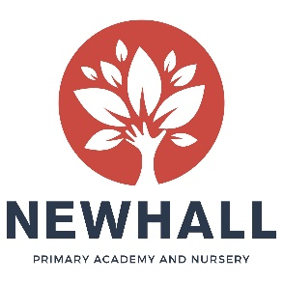

Level 3 Early Years Practitioner
(With responsibility for leading the Baby Room)
Person Specification

Pay Scale/Grade: | Essex LGS Point 14-18 (£17,681 - £18,870) plus OFA £597 pro rata
Reports to: | Nursery Manager
Responsible for: | Leading teaching, learning and quality care in the EYFS
Liaison with: | Academy and Nursery Staff, Headteacher, Senior Leadership Team, Children, Parents/Carers

The selection decisions will be based on the criteria outlined below. At each stage of the process, an assessment will be made by the appointment panel to determine the extent to which the criteria have been met.

When completing your covering letter, application form and person specification form, you should ensure that you address each of the selection criteria and provide supporting evidence of how you meet the criteria through reference to work or other relevant experience.

Qualifications: | - NVQ Level 3 in Children’s Care, Learning and Development  - CACHE Level 3 Diploma in Child Care and Education  (Or equivalent)
Skills, aptitude, knowledge and experience: | - Previous experience of caring for, or working with children aged 0-2 in a voluntary or paid capacity  - An understanding of the EYFS Framework and Early Learning Goals  - Knowledge of the National Standards for the regulation of Childcare provision  - A commitment to the provision of high quality childcare  - A positive approach to learning and gaining new skills through teamwork and training opportunities.
Newhall Ethos | - Capacity to work well with children across all age groups  - Fully supportive of the aims & ethos of the Academy and Nursery  - Ability to ensure that the atmosphere is welcoming  - Ability to support the vision for a high quality learning environment which promotes spiritual, moral, social and cultural development
Personal Attributes | - Energy and enthusiasm  - Reliability and integrity  - Sense of humour  - A commitment to the ethos of the Academy and Nursery  - Commitment to your continuing professional development  - Vision and creativity  - Adaptability to changing circumstances & ideas.
Safeguarding | - Commitment to the safeguarding and protection of children and to the personal development of our pupils  - Understanding of the issues surrounding the safeguarding of children and commitment to child welfare and safety

Note to applicants:
Newhall Primary Academy and Nursery is committed to safeguarding and promoting the welfare of children and young people and expects all staff to share this commitment.

