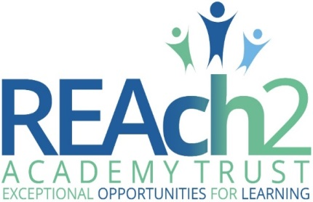

Safeguarding and
Child Protection policy

Audience: | Parents  Academy staff and volunteers  Local Governing Bodies  Trustees  Regional Boards  Local Authorities
Approved: | Trustees – July 2018
Other related policies: | Attendance; Behaviour; Code of Conduct; Disciplinary; E-safety; Health and Safety; Missing Pupils; Recruitment; Whistleblowing
Policy owner: | Helen Beattie, Trust Safeguarding Lead
Policy model: | Compliance: all REAch2 schools use this policy
Review: | Annually as a minimum, and in line with new editions of Keeping Children Safe in Education
Version number: | 1.0 (July 2018)

REAch2 Safeguarding and  Child Protection policy | 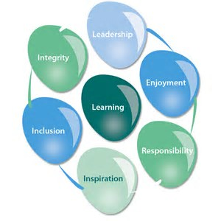

At REAch2, our actions and our intentions as school leaders are guided by our Touchstones:

Integrity | We recognise that we lead by example and if we want children to grow up to behave appropriately and with integrity then we must model this behaviour
Responsibility | We act judiciously with sensitivity and care. We don’t make excuses, but mindfully answer for actions and continually seek to make improvements
Inclusion | We acknowledge and celebrate that all people are different and can play a role in the REAch2 family whatever their background or learning style
Enjoyment | Providing learning that is relevant, motivating and engaging releases a child’s curiosity and fun, so that a task can be tackled and their goals achieved
Inspiration | Inspiration breathes life into our schools. Introducing children to influential experiences of people and place, motivates them to live their lives to the full
Learning | Children and adults will flourish in their learning and through learning discover a future that is worth pursuing
Leadership | REAch2 aspires for high quality leadership by seeking out talent, developing potential and spotting the possible in people as well as the actual
Contents

 | Page
POLICY OVERVIEW | 3
POLICY PRINCIPLES IN DETAIL | 4 – 5
IMPLEMENTATION | 7
ANNEXES
Annex 1 – types of abuse | 8 – 11
Annex 2 – contact information | 12
Annex 3 – recording safeguarding concerns | 13
Annex 4 – local agency procedures | 14
Annex 5 – managing allegations | 15 – 16

POLICY OVERVIEW

Overarching Principles
We recognise that academies and academy personnel are in a unique position in their care of children. The responsibility for all staff to safeguard pupils and promote their welfare, as stated in Section 175 of the Children’s Act (2002) is one that is central to our ethos, our policies and our actions. All children are deserving of the highest levels of care and safeguarding, regardless of their individual characteristics or circumstances, and we are committed to applying this policy to ensure effective levels of safeguarding and care are afforded to all of our pupils. This policy sets out guidance and procedures that our academy will take to ensure appropriate action is taken in a timely manner to safeguard and promote the welfare of our pupils. Its contents are intended to be in accordance with all relevant Government guidelines and legislation, as well as the inter-agency procedures provided by Essex Local Safeguarding Children’s Board. In Essex, all professionals must work in accordance with the SET Procedures (ESCB, 2018).

Intended impact
- To enable all pupils to feel safe and cared for whilst at our academy, and to ensure that they have a safe place and safe people to whom they can turn.
- To enable all adults involved with our academy to be fully equipped to fulfil their responsibilities in effectively promoting the safeguarding and welfare of all of our pupils.

Roles & responsibilities:
- Pupils will: adhere to academy rules regarding conduct and safe behaviour; report anything that worries them to a trusted adult.
- Parents/carers will: work collaboratively with academy staff to promote the safety of their children and of other pupils; support our academy to teach pupils about keeping safe by reinforcing key safety messages; report any safeguarding concerns regarding their own children or another pupil to the academy.
- The academy will: ensure that all pupils have a safe learning environment and are taught about how to keep safe; train and support all adults involved with our academy to appropriately identify and respond to any pupil at risk of harm; work collaboratively with parents and professional agencies to safeguard our pupils.
- Governors will: ensure this policy is applied robustly throughout the academy; review it regularly (annually at a minimum) to ensure the effectiveness and rigor of safeguarding practice at our academy.
- REAch2 central staff will: know, understand and follow the safeguarding procedures for each academy within which they work; undertake relevant regular training and updates to ensure their skills and knowledge support them to meet their safeguarding responsibility.
- REAch2 Regional Safeguarding Leads will: advise and challenge academies and their staff to support them in deploying best practice to meet their statutory safeguarding responsibilities.

How this relates to national guidance & requirements:
Statutory safeguarding and child protection practice for schools and academies is outlined in the following legislation and documents, with which this policy intends to be in accordance:
- Legal: Section 175, Education Act (2002); Section 26, Counter Terrorism and Security Act (2015)
- Government: Working Together to Safeguard Children (2018); What To Do if You’re Worried A Child is Being Abused (2015); Keeping Children Safe in Education (2018); Children Missing Education (2016); Sexual Violence and Sexual Harassment between children in schools (2018); Designated Teacher for Looked After and Previously Looked After Children (2018)
- Ofsted: Inspecting safeguarding in early years, education and skills settings (2016)

Any key definitions:
Safeguarding and promoting the welfare of children is defined in Keeping Children Safe in Education (2018) as: ‘protecting children from maltreatment, preventing impairment of children’s health or development, ensuring that children grow up in circumstances consistent with the provision of safe and effective care, and taking action to enable all children to have the best outcomes.’
Policy principles in detail

The role and responsibilities of the Designated Safeguarding Lead
- We will appoint a senior member of staff from our academy’s leadership team to act as our Designated Safeguarding Lead (DSL) This person will coordinate all safeguarding and child protection procedures at our academy, and will take lead responsibility for this area, which will be specified in their job description.
- We will also appoint one or more Deputy Designated Safeguarding Leads, who will be trained to the same level as the Lead, will have their Deputy DSL role included in their job description, and to whom activities may be delegated.
- During school hours, the Designated Safeguarding Lead or their Deputy will be available to discuss any safeguarding concerns, either in person or, in exceptional circumstances, via phone or other modes of communication.
- The Designated Safeguarding Lead and their Deputies will undergo suitable training, including Prevent training, to equip them with the skills and knowledge required to undertake their role, which will be updated at a minimum every two years; in addition, their skills and knowledge will be refreshed at regular intervals, annually at a minimum.
- The Designated Safeguarding Lead and their Deputies will ensure that all staff know and understand the safeguarding and child protection procedures at our academy, as well as learning and working effectively with the local inter-agency procedures for assessment of early help needs and for referrals of suspected cases of abuse.
- The Designated Safeguarding Lead is expected to oversee and manage all referrals of suspected abuse that are made to Social Care, Police, Channel, and other agencies, and will also support and liaise with any academy staff who have either been involved in making such referrals or who have concerns about a pupil which may subsequently require a referral.
- The Designated Safeguarding Lead and their Deputies will maintain detailed and secure electronic records of any concerns and referrals, and all subsequent follow up actions/ communications. Records should be actioned and updated within 24 hours of the event taking place.

Induction and training
- We will train all academy staff and volunteers in line with their local LSCB procedures to equip them with the necessary skills and knowledge to support them to fulfil their safeguarding responsibilities. This will take place upon induction, no later than 1 month after employment commences, and will be refreshed regularly, no less than annually, throughout the course of their work with our academy.
- Training and refresher sessions will reinforce understanding of the types of abuse, including specific safeguarding issues; the adult’s role in recognising and responding to abuse; and the academy’s processes for recording and following up on any concerns. Policies, policy updates, and statutory information will also be shared during induction and refresher sessions (see page 7, ‘Implementation’, for further information)

Types of abuse and specific safeguarding issues
- We recognise that adults working in our academy are in a unique position to recognise and respond to signs of abuse, and that these can take place and manifest in a variety of ways, including peer on peer.
- Induction training and regular refresher sessions will equip staff and volunteers to understand the different types of abuse, including specific safeguarding issues such as Female Genital Mutilation and radicalisation, and support them to know how to respond to any concerns.
- Annex 1, pages 8 – 11, details our approach to dealing with the risks posed by abuse, and how we identify and respond to any signs of abuse.

Contextual safeguarding
- Children are subject to possible risk at home, school and in their local community and environment, and we recognise that in order to effectively safeguard our pupils and promote their welfare that we need to understand any specific issues arising in the local area that can affect the risk posed to them.
- Significant risks known to be prevalent in the area and community local to our academy are: drugs/county lines
- We will work with local partners, including Social Care and Police, to ensure that we stay alert to any emerging contextual risks, and to ensure that assessment of risk for any of our pupils includes appropriate reference to their local community and environment.

Processes, procedures, and inter-agency liaison
- Where there are concerns about the safety of a child, the sharing of information in a timely and effective manner between organisations can reduce the risk of harm. Whilst the Data Protection Act 1998 places duties on organisations and individuals to process personal information fairly and lawfully, it is not a barrier to sharing information where the failure to do so would result in a child or vulnerable adult being placed at risk of harm. Similarly, human rights concerns, such as respecting the right to a private and family life would not prevent sharing where there are real safeguarding concerns. Fears about sharing information cannot be allowed to stand in the way of the need to safeguard and promote the welfare of children at risk of abuse or neglect.
- Well-kept records are essential to good child protection practice. Our academy is clear about the need to record any concern held about a child or children within our academy, the status of such records and when these records should be shared with other agencies.
- Any member of staff receiving a disclosure of abuse or noticing signs or indicators of abuse, will record it as soon as possible, noting what was said or seen (if appropriate, using a body map to record), giving the date, time and location. This will be logged on CPOMS (See Annex 3), a secure software application for monitoring child protection, safeguarding and a range of pastoral and welfare issues which all staff have access to. Training and refresher sessions will reinforce effective techniques for recording concerns, and will highlight the importance of accurate written records.
- Upon receiving a concern which indicates a suspicion of abuse, the Designated Safeguarding Lead or their Deputy will follow local inter-agency procedures, local information sharing protocols and statutory/legal expectations in deciding if a referral to an external agency is warranted; This will also be recorded on CPOMS accordingly. It is important to note that whilst a referral would typically be made by the Designated Safeguarding Lead or their Deputy, any member of staff can make a referral, and appropriate information will be signposted to all staff to support them to do so.
- Any records related to child protection are kept within CPOMS in an individual child protection file for that child (which is separate to the pupil file). All child protection records are stored securely and confidentially on CPOMs and will be retained for 25 years after the pupil’s date of birth, or until they transfer to another school / educational setting.
- In the case of a referral being made due to risk of significant harm, the referrer will make a detailed record of their actions on CPOMS, including: dates and times of any conversations; the name and role of any professionals that were spoken to; the outcome of the referral; any actions that the referrer and the agency receiving the referral have agreed to;
- Any disagreements between the referrer and a professional or agency will be appropriately voiced and discussed, with the referrer following appropriate escalation procedures if they remain dissatisfied and if the circumstances warrant. Any disagreements or escalation will be recorded in writing by the referrer and logged on CPOMS;
- In the case where a concern does not suggest a risk of significant harm but the pupil remains in need of additional support, the Designated Safeguarding Lead will liaise with parents and, with their permission, follow local Early Help Assessment guidelines in order to source the most appropriate support;
- The Designated Safeguarding Lead or their Deputy will be a proactive contributor to any strategy meeting, Child Protection conference/review, core group, Early Help Assessment, and Team Around the Family meeting, and will attend professionals’ meetings where requested, providing appropriate written and/or verbal education and welfare reports related to the child and their family as requested by agencies and in line with statutory information sharing guidance.
- Records of all safeguarding work from early help to child protection will be made on the child’s safeguarding record on CPOMs. Any actions arising from a concern will be followed up and documented, and records of any communication with school staff, external agencies and parents related to safeguarding will be documented on the child’s record within 24 hours.
- Minutes and action plans of meetings will be scanned and retained on a child’s safeguarding record, with relevant actions being fed back to the appropriate members of the team, and any progress towards meeting required actions and outcomes also recorded.
- Where a pupil transfers from our academy to another school / educational setting (including colleges), a copy of their child protection records will be forwarded to the new educational setting within 10 working days of the academy receiving confirmation of new school, from whom confirmation of receipt will be required.
- Where a pupil joins our academy, we will request child protection records from the previous educational establishment (if none are received).

Early Help
- We recognise that early intervention when a child or family is starting to show signs of concern can be critical to ensure that the right help and support is sourced, preventing any further escalation of issues or a decline in the child’s safety and wellbeing.
- We recognise that partnerships with parents and carers is crucial in identifying the need for early help and for effective collaboration to improve the life chances for pupils. We work proactively with parents and carers to develop effective relationships between home and school, and to promote the benefits of early help and intervention to support their child.
- Any child can benefit from early help, but we are particularly alert to the needs of: SEND pupils; young carers; pupils vulnerable to anti-social behaviour, gangs, exploitation and radicalisation; pupils currently in or recently returned from care or those being privately fostered; pupils misusing drugs or alcohol or living in households where drugs or alcohol are being misused; pupils living in households with domestic violence or parental mental health concerns.
- In a case where a concern about a pupil does not suggest a risk of significant harm but they remain in need of additional support, the Designated Safeguarding Lead will liaise with parents and, with their permission, follow local Early Help Assessment guidelines in order to source the most appropriate support.
- The Designated Safeguarding Lead or their Deputy will be a proactive instigator and/or contributor to any Early Help Assessment and subsequent Team Around the Family meeting and, as above, will lead or attend professionals’ meetings where requested, providing appropriate written and/or verbal education and welfare reports related to the child and their family as requested by agencies.

Safer recruitment and the Single Central Record
- We recognise that it is critical to ensure that our pupils are taught and supported by adults who are safe to do so, and that we are responsible for promoting a culture of safety within our academy environment by preventing unsafe adults from having access to it.
- In line with expected practice for safer recruitment, a minimum of one member of academy staff will undertake training in ‘Safer Recruitment’, and will be present on any interview panel.
- Our School Business Manager/Office Manager will maintain a Single Central Record, detailing the required and relevant recruitment and vetting checks undertaken on all school employees, volunteers, Governors, agency workers and third-party staff.
- Headteachers will oversee the SCR and be accountable for its accuracy, checking it regularly and termly as a minimum, making a record of the check and any subsequent actions that arise. The designated governor will check the SCR prior to every Full Governing Body meeting, also making a record of the check and any subsequent actions that arise.
- The Single Central Record will be supported by files containing appropriate supporting evidence for recruitment and vetting checks, held in line with Data Protection legislation.
- Please see our Recruitment policy for further detail regarding our adherence to safer recruitment principles for staff and volunteers.

Teaching pupils to stay safe
- We recognise the importance of teaching our pupils how to stay safe, and that opportunities to do so form an integral part of a broad and balanced curriculum.
- Learning opportunities will take the form of: PSHE lessons, Computing lessons, Sex and Relationships education, assemblies, circle time, class/form time, and visiting speakers, as well as smaller group and focussed intervention for particular vulnerable pupils as needed.
- The ethos of our school and its curriculum will support the promotion of British Values, which is known to build resilience to exploitation and radicalisation.
- We will model and teach safe behaviour and appropriate language (including how to stay safe online), and will promote a culture of safety within our academy where everyone’s opinion is valued and everyone has someone safe to whom they can turn.
- We will actively collect feedback from our pupils, and will regularly engage with Pupil Voice to seek the views of pupils on their experiences of feeling safe at our academy and within their communities.

Implementation

This policy applies to all adults involved with our academy, including paid staff, volunteers, visitors, and Governors. It will be publically available on our academy website, and will be available in paper form upon request from the office. We will also make available and/or signpost all relevant statutory and legislation safeguarding and child protection documentation to staff and volunteers for their reference.

At the beginning of the academic year all academy staff and volunteers, including Governors, will be issued with a copy of this policy, along with a copy of the academy’s Code of Conduct, Whistleblowing policy, behaviour policy, e-safety, acceptable use & social media policy/ies, any additional information about responding to children missing in education (CME), together with Part 1 and Annex A of Keeping Children Safe in Education (2018) They will be required to sign a confirmation that they have received, read and understood these documents, and that they agree to abide by their contents.

Any new staff who join our academy subsequent to the annual policy issue will receive a specific safeguarding induction, where this policy, plus our academy’s Code of Conduct, Whistleblowing policy, behaviour policy, e-safety, acceptable use & social media policy/ies, any additional information about responding to children missing in education (CME), together with Part 1 and Annex A of Keeping Children Safe in Education (2018) will be shared and discussed. These staff will also be required to sign a confirmation that they have received, read and understood these documents, and that they agree to abide by their contents.

This policy will be reviewed annually by REAch2 Academy Trust in line with updates of statutory guidance, and additionally on a regular basis by academy Governors, led by the named academy Safeguarding Governor, to assess the impact of our academy’s processes and procedures in safeguarding pupils and promoting their welfare.

ANNEX 1 – types of abuse

We are aware that all children are potentially vulnerable to abuse. It can take place at home, in the academy environment, and in the wider community; be committed by adults and by other children; be inflicted by people known to the child and by strangers; be a consequence of an act of deliberate harm and from failing to take necessary steps to prevent the child from coming to harm.

The four main types of abuse referred to in Keeping Children Safe in Education (2018) are:
- physical
- emotional
- sexual
- neglect

High quality training, which is regularly updated, ensures all adults involved with our academy are familiar with the definitions of abuse, actions that constitute each of the four categories, and the signs of each type of abuse, so that pupils who may be in need of help or protection are appropriately identified.

In addition to the above, we recognise that there are a number of specific safeguarding issues that require special consideration due to their complex nature. All staff and volunteers will be issued with a copy of Part 1 and Annex A of Keeping Children Safe in Education (2018), containing the full list of specific safeguarding issues and the accompanying guidance documents, with which they are expected to be familiar.

Peer on peer abuse:
- Some children may abuse their peers, which can manifest in many ways, including bullying, physical abuse, online abuse, sexual harassment and sexual violence, ‘sexting’ and initiation/hazing.
- Harmful or abusive behaviour between pupils in our academy is not tolerated: we do not believe that it is to be expected, or to be accepted. We recognise that peer on peer abuse is more likely to see boys as perpetrators and girls as victims; staff will be alert to this, but will ensure that all incidents of peer on peer abuse are taken equally seriously regardless of the identity or gender of the perpetrator and victim/s.
- Any report of peer on peer abuse will be swiftly investigated, recorded and responded to in line with the school’s behaviour and anti-bullying policies. Where appropriate, this may include school sanctions, exclusion, referral to Social Care and/or Police. Victim/s will be reassured, and both victim/s and perpetrator will receive appropriate support and guidance to safeguard and protect them and to ensure that their wellbeing is being promoted.
- We will use lessons and assemblies to help pupils understand, age-appropriately, what abuse is and what the academy’s policy and expectations are of their behaviour and conduct to each other, encouraging them to tell a trusted adult if someone is behaving in a way that makes them feel uncomfortable.
- Part 5 of Keeping Children Safe in Education (2018), Child On Child Sexual Violence and Sexual Harassment, will be made available for all staff.

Gangs and youth violence
- We recognise that children are vulnerable, at any age, to being drawn into a gang environment and being targeted as perpetrators, or victims, of violence to others.
- We understand the positive impact that education, and spotting and responding to early warning signs of gang behaviour and violence, can have on affecting a positive outcome for a child and for building resilience to gang culture.
- We will be vigilant to any signs of our pupils being drawn into, or affected by, gangs and youth violence, and will work with local agencies to safeguard any perpetrators and/or victims.

Child Exploitation, including Child Sexual Exploitation
- It is understood that any child of any age is vulnerable to the risks of exploitation, including child sexual exploitation, and that this is not limited to older children or adolescents. Children can also be used to exploit other children.
- We are alert to the signs and indicators of a pupil becoming at risk of, or subject to, all forms of exploitation, including but not limited to: gang and violence-related activity; criminal and anti-social behaviour; going missing from education; underage and illegal sexual activity; risky behaviour, including behaviour online; awareness, knowledge and use of alcohol and illegal substances.
- The Designated Safeguarding Lead is the academy’s named professional for issues related to exploitation, and will work with local agencies as required to safeguard pupils at risk of, or subject to, exploitation.

Children with family members in prison, and children in the court system
- We recognise the significant impact that a parent being in prison can have on a child’s outcomes, academically, emotionally and financially.
- We also recognise that children can be required to give evidence in court, either as victims or as witnesses, and that this is an experience likely to have a significant impact on them.
- Both of the above issues require bespoke support to ensure that the impact on the child’s wellbeing is minimised. We will seek appropriate professional support for children in these circumstances, and ensure that pastoral provision actively supports and monitors their progress.

Domestic abuse
- Witnessing or experiencing domestic abuse, defined as controlling, coercive, threatening, violent and abusive behaviour between partners and/or family members, poses a serious risk to children, and we recognise the serious and long lasting impact it can have on their wellbeing.
- We will train our staff to know and understand the risks posed by domestic violence, regardless of whether the child has been physically injured or not, and to recognise any incident of domestic violence witnessed or experienced by a child as a potential safeguarding issue. Where necessary, we will work with local agency professionals to respond to any reported incidents of domestic violence.

Homelessness
- We recognise that homelessness, and the risk of homelessness, places a child’s welfare at significant risk, being at risk of poverty, exploitation, and becoming missing from education, amongst others.
- Timely intervention when a risk of homelessness is first identified is critical in preventing a situation from escalating and homelessness becoming a reality. We will work closely with families identified to be at risk, and with professional from relevant local agencies, to put appropriate measures into place to minimise the risk of homelessness.

‘Honour based’ violence, including Female Genital Mutilation, Breast Ironing and Forced Marriage
- ‘Honour based’ violence refers to actions committed under a belief of protecting or defending the honour of a family or community. Regardless of the motivation or circumstances, we recognise that these acts are illegal and abusive, and should be responded to as such.
- We are aware of, and will adhere to, the legal duty placed on teachers to notify the Police of any confirmed cases of Female Genital Mutilation carried out on a girl under the age of 18.
- We are alert to the signs and indicators of a child being at risk of ‘honour based’ violence, and will work with local agencies as required to safeguard these pupils.

Radicalisation
- Under the Counter Terrorism and Security Act (2015) academies are required to have ‘due regard to the need to prevent people from being drawn into terrorism’, otherwise known as the ‘Prevent duty’.
- We are alert to the signs and indicators of a child showing signs of radicalisation and of being at risk of being drawn into terrorism, and will work with local agencies and the Channel programme as required to safeguard these pupils.
- The Designated Safeguarding Lead is the academy's named professional for radicalisation, who has an appropriate knowledge of the risks associated with the local area.
- We recognise that a broad and balanced curriculum will support pupils in developing resilience to extremist ideology; therefore, learning opportunities should promote pupils’ spiritual, moral, cultural, mental and physical development, prepare them for the opportunities, responsibilities and experiences of life, promote community cohesion and British values, and provide a safe space in which they can understand, discuss and learn to challenge sensitive topics.

Children Missing Education
- We recognise that a child missing from education can be an indicator of abuse or neglect, including a risk of exploitation, ‘honour based’ violence and radicalisation, as outlined above.
- Robust procedures are in place for monitoring and responding to pupil attendance, as outlined in our academy’s Attendance policy, including, where possible, recording more than one emergency contact for each pupil.
- In line with Children Missing Education (2016) and SET procedures, we will work with local agencies and make timely referrals as required to ensure that circumstances where children are missing from education are swiftly and appropriately responded to.

Online safety
- Technology has become a significant risk factor in safeguarding children, and we recognise our responsibility to protect our pupils from the risks of inappropriate content and contact from inappropriate people, as well as educating them about how to conduct themselves safely online.
- Staff are alert to the risks posed to pupils via their use of technology, and receive appropriate training to support them in ensuring that risks are swiftly identified and responded to.
- Our Computing curriculum, together with assemblies and other learning opportunities, will equip our pupils with the necessary knowledge and skills to take best advantage of the many opportunities that technology brings whilst acting safely and responsibly whilst using technology.
- Please see the Academy’s E-safety and Social Media/Acceptable Use (Appendix 1 of Staff Code of Conduct)/Computing policies for further information.

Children with Special Education Needs and Disabilities (SEND)
- We recognise that pupils with SEND face additional challenges in keeping safe, and that they may be subject to increased risk by virtue of their special need or disability. Their physical and emotional needs, behaviour, mood, difficulties with communication, proneness to isolation and to bullying all make them more vulnerable to abuse and more vulnerable to abuse being overlooked or ascribed to a different cause.
- Staff working with pupils with SEND who are non-verbal or have limited communication will be particularly vigilant of potential signs of abuse, such as changes in mood and behaviour, suspicious marks, etc, and will promptly respond to these signs by following the safeguarding procedures detailed above.
- We ensure that pupils with SEND receive appropriate pastoral provision, which, if necessary, may be additional to that provided to non-SEND pupils, and that they are taught in a way that is appropriate to their developmental stage about keeping safe and about sharing any worries or concerns with a trusted adult.
- Use of ‘reasonable force’, referring to use of physical contact to control or restrain a pupil, is sanctioned in schools when it is being used to safeguard. The additional vulnerabilities of pupils with SEND in the use of reasonable force is known and understood, and we are committed to reducing the risk posed to these pupils and limiting the need for use of reasonable force through our pastoral support and behaviour management systems.
- From time to time, pupils with SEND may need to receive additional support, or part-time/full-time education, from an Alternative Provision so that their needs can best be met. We will take responsibility for assuring ourselves that the policies and procedures for keeping children safe at the Alternative Provision, including those relating to safeguarding and to safer recruitment, are sufficiently robust and are in line with statutory expectations.
- Please see the Academy’s SEND/Inclusion and behaviour policies for further information.

Looked After Children, and previously Looked After Children
- Children are most commonly taken into care following abuse or neglect; consequently, pupils who are Looked After or previously Looked After, including those who have been adopted from care or are subject to care orders, can be vulnerable as a result of their historical experiences, as well as with their current care arrangements.
- We will appoint a Designated Teacher, who is responsible for monitoring the progress and wellbeing of all Looked After Children, and for liaising with both academy staff and professionals from external agencies to ensure appropriate provision to meet their academic, developmental and welfare needs. The Designated Teacher will also be responsible for monitoring the progress and wellbeing of all previously Looked After Children, ensuring that they have appropriate provision to meet their needs.
- The Designated Teacher will be responsible for ensuring that a Looked After Child’s PEP is available, up to date and regularly reviewed to ensure it is having an impact on the pupil’s attainment and wellbeing.
- The Designated Teacher will also be responsible for establishing effective partnerships with the child’s carers.

ANNEX 2 – contact information

Name of Designated Safeguarding Lead | Debbie Gayler
Role of Designated Safeguarding Lead | Headteacher
Contact details for Designated Safeguarding Lead | head@newhallacademy.org

Name of Deputy Safeguarding Lead/s (School) | Jenny O’Neill
Role of Deputy Safeguarding Lead/s | EYFS Lead
Contact details for Deputy Safeguarding Lead/s | Jenny.o’neill@newhallacademy.org

Name of Deputy Safeguarding Lead/s (Nursery) | Maria Sorce
Role of Deputy Safeguarding Lead/s | Nursery Manager
Contact details for Deputy Safeguarding Lead/s | nursery@newhallacademy.org

Name of Deputy Safeguarding Lead/s (Nursery) | Rosina Maddams
Role of Deputy Safeguarding Lead/s | Nursery Deputy Manager
Contact details for Deputy Safeguarding Lead/s | Rosina.maddams@newhallacademy.org

Name of Chair of Governors | Paul Mcfarlane
Contact details for Chair of Governors | Via office@newhallacademy.org, please mark confidential
Name of Safeguarding Governor | Mr Tom Webb – Not appointed yet (CofG in interim)
Contact details for Safeguarding Governor | Via office@newhallacademy.org, please mark confidential

Essex Social Care contact details | 0345 603 7627
Essex Out of hours Social Care contact details | 0345 606 1212

Essex LADO name | Essex Duty LADO
Essex LADO contact details | 03330 139 797

Essex Prevent agency name | Sue McCann
Essex Prevent agency contact details | sue.mccann@essex.gov.uk
Essex police Prevent Team details | DC Rachael Harris Tel: 01245 452196

ANNEX 3 – Logging a safeguarding concern on CPOMS

Login to CPOMS.

ANNEX 4 – local agency procedures

Children and Families Hub Flow Chart

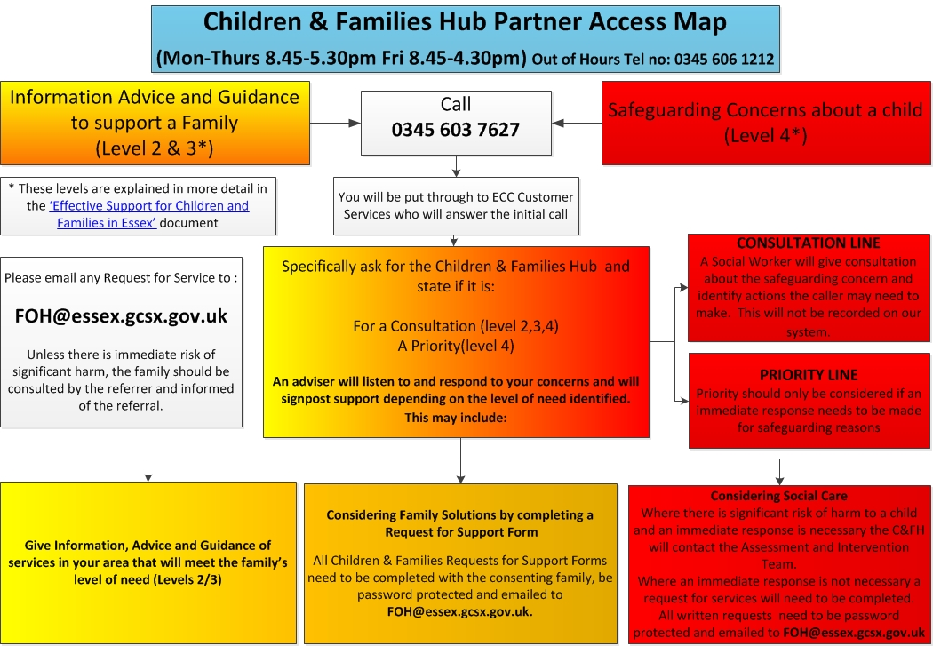

Essex Windscreen of Need and levels of intervention

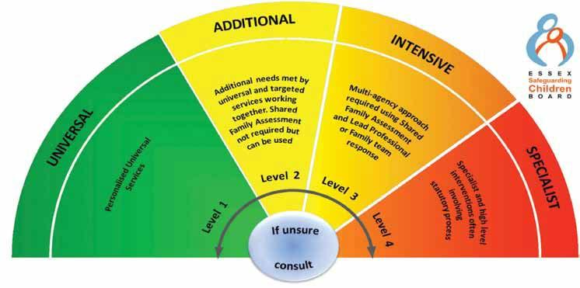

All partners working with children, young people and their families will offer support as soon as we are aware of any additional needs. We will always seek to work together to provide support to children, young people and their families at the lowest level possible in accordance with their needs
Children with Additional needs are best supported by those who already work with them, such as Family Hubs or schools, organising additional support with local partners as needed. When an agency is supporting these children, an Early Help Plan and a Lead Professional are helpful to share information and co-ordinate work alongside the child and family.
For children whose needs are Intensive, a coordinated multi-disciplinary approach is usually best, involving either an Early Help Plan or a Shared Family Assessment (SFA), with a Lead Professional to work closely with the child and family to ensure they receive all the support they require. Examples of intensive services are children’s mental health services and Family Solutions.
Specialist services are where the needs of the child are so great that statutory and/or specialist intervention is required to keep them safe or to ensure their continued development. Examples of specialist services are Children’s Social Care or Youth Offending Service. By working together effectively with children that have additional needs and by providing coordinated multi-disciplinary/agency support and services for those with intensive needs, we seek to prevent more children and young people requiring statutory interventions and reactive specialist service

Essex PREVENT Referral Chart:

ANNEX 5 – managing allegations

Keeping Children Safe in Education (2018) defines an allegation of abuse against a member of staff as any case in which it is alleged that an adult (including volunteers) at the school or academy has:
- behaved in a way that has harmed a child, or may have harmed a child
- possibly committed a criminal offence against or related to a child
- behaved towards a child or children in a way that indicates he or she would pose a risk of harm to children

This policy is designed to work in full accordance with the statutory guidelines set out within Part Four, Keeping Children Safe in Education (2018), as well as with local guidelines issued by Essex Local Authority (SET Procedures 2018), both of which set out each stage of the process for managing allegations in detail. Headteachers, members of the Senior Leadership Team and the Chair of Governors will familiarise themselves with both of these documents; however, key principles that we will follow are detailed below.

Staff awareness
- All staff and volunteers will be issued with our academy’s Code of Conduct and our Whistleblowing policy, which is intended not only to support them in adopting safe practice in their work with children but also to advise on how to report any concerns about the conduct of a colleague.
- Additionally, all staff and volunteers are signposted to the Ofsted Whistleblower Helpline, 0300 123 3155, and to the NSPCC Whistleblowing Advice helpline, 0800 028 0285.

Headteacher, SLT and Governor awareness
- The Headteacher, members of SLT (in case of the Headteacher’s absence) and the Chair of Governors (in case of the allegation being against the Headteacher) will know the name and contact details for the Local Authority Designated Officer (LADO), with whom contact will be made as soon as possible upon receipt of an allegation against a member of staff or volunteer at our academy, and always within one working day.
- If further investigation or action is required, the person referring the concern to the LADO will then be nominated as the ‘case manager’. If the specific circumstances warrant, or if the case is unusually complex, the case manager role may be taken on by a professional independent to our academy, i.e. a colleague from within REAch2 Academy Trust.

Information sharing
- When directed to by the LADO, the case manager will inform the accused person of the allegation and will be given as much information as possible about its nature. We have a duty of care to our employee/volunteer, and will provide effective support to anyone in this situation, as well as ensuring that the matter is dealt with quickly, fairly and consistently.
- As directed by the LADO, the case manager will also tell the parents of the child or children involved of the allegation (if they are not already aware) and will keep them informed as to the progress and outcome of the process.

Managing the situation
- As directed by the LADO, we will assess the possible risk posed by the accused individual if they are to continue in their role. This assessment may result in suspension if the risk is considered sufficient and if all suitable alternative options have been considered.
- If a member of staff or volunteer who is judged to be unsuitable to work with children resigns or their services cease to be used, we will assess the situation against the published DBS criteria and will follow up with a referral where necessary. A compromise or settlement agreement will not be used in cases where this would prevent a referral to DBS being made, as to do so could result in a criminal offence and is non-compliant with our legal duty.
- One-off and/or repeated allegations of malicious, false, unfounded or unsubstantiated conduct will not be referred to in employer references.
- Where an allegation has been found to be malicious, we will consider whether to take further action, either via the Behaviour policy (in the case of a pupil) or via discussion with the Police (in the case of a parent or other adult)

Record keeping
- Full details of each stage of the allegations process will be recorded in writing by the Case Manager.
- Where an allegation has been found to be malicious, i.e. the allegation is disproved and there has been a deliberate attempt to deceive, all details and records will be removed from the person’s personnel file.
- For allegations found to be substantiated, false, unfounded or unsubstantiated, details of the allegation and the investigation process, including the outcome, will be kept as per the Disciplinary policy, but usually separately and confidentially to the person’s personnel file, with a copy also provided to the person concerned.
- Records will be retained for a period of 10 years from the date of the allegation, or until the accused has reached pension age (if this is sooner)

Learning lessons
- As soon as is practicable, the Governing Body will convene to review the facts of the case, reflect on any lessons to be learned, and implement any needed changes to policy and/or procedure. Where applicable, this will include reference to any feedback given by the LADO.

