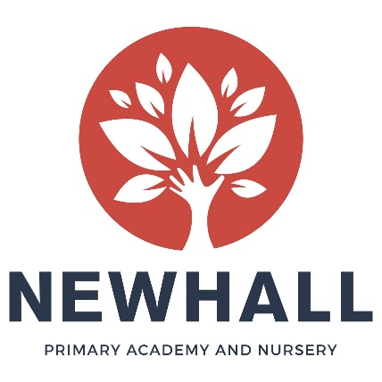
Class Teacher Vacancies (EYFS and Key Stage One)
NQTs welcome to apply

Overview
Are you an outstanding Practitioner? Do you want the rare opportunity to be part of our growing Newhall family? If so, we would love to hear from you! At Newhall Primary Academy and Nursery we are looking for Class Teachers to work in Early Years and Key Stage One. We are looking for teachers who are up for a challenge and want to get stuck in with all aspects of our academy life!

Post Title: | Class Teacher
Contract type: | Permanent
Location: | Newhall Primary Academy
Working hours: | Full-time
Start date: | 1st September 2019
Salary: | Main Pay Scale

About us
Newhall is a brand-new, state of the art academy on the Newhall development in Harlow, with the capacity for 420 children. The Primary Academy currently has 47 children on roll. It will grow year-on-year until it reaches full capacity (60 per year). The Nursery has capacity for 56 children and is open all year round from 7.30am until 6pm. It offers both funded and private day care places.

The Academy and Nursery opened in September 2018 with 15 permanent staff and we are now seeking additional staff to join us and be part of the unique opportunity to build and grow the setting from its infancy. There is no doubt about it, setting up the Academy and Nursery from scratch takes vision, dedication and hard-work, but being part of that exciting and rare journey is exciting and it will be very rewarding to see the Academy and Nursery take shape over the next few years. To see more information about Newhall, please visit our website.

The children at Newhall are enthusiastic, keen to learn and a joy to teach. We are also supported by a growing community, including very supportive and engaged parents and an active Governing Body.

About the role
As one of the first members of staff to be appointed to Newhall Primary Academy and Nursery, you will help shape its future direction. You will work alongside our Senior Leadership Team and other Newhall staff to help create an exciting and vibrant setting, where all children thrive.

You will be based in the main Academy building and you will work in partnership with other Class Teachers. You will be supported by experienced Senior Leaders and be part of the wider Academy and Nursery Team.

There is potential for your role to grow and adapt with the academy over the coming years, with leadership opportunities as the school grows. You will be expected to lead a curriculum subject area, unless you are an NQT.

What we’re looking for:
We are looking for good and outstanding classroom practitioners within the Early Years or Key Stage One. You will be someone who is highly driven and motivated, has an eye for detail, and can work flexible and creatively.
The successful candidate will have:
- The motivation to achieve the very best for the children in our care and be relentless in the pursuit of excellence
- Proven experience as an effective good and outstanding classroom teacher
- Experience of working with children of different ages within the Early Years and Key Stage One
- Excellent communication skills and a good sense of humour
- A positive team player and be able to use your own initiative
In return we can offer:
- A firm commitment to you and your professional development
- Friendly, supportive, enthusiastic and hardworking colleagues, staff and Governors
- A growing learning community
- Encouragement to develop new ideas and the opportunity to make a real difference
-Coaching and mentoring from a member of academy’s Senior Leadership Team
-Fantastic trust-wide CPD opportunities
-Vast opportunities for career progression

How to apply
We hope you will take the time to find out more about our new academy and experience our warm welcome. For further information about the role, or to arrange an informal discussion, please contact the school on 01279 215480 or email office@newhallacademy.org.

Completed applications should be sent via e-mail to head@newhallacademy.org by 28th February 2018.

Short-listed candidates will be invited for interviews w/c Monday 11th March 2018. Newhall Primary Academy is committed to safeguarding and promoting the welfare of children, young people and vulnerable adults and expects all staff and volunteers to share this commitment. The successful applicant will be subject to an enhanced DBS check.

