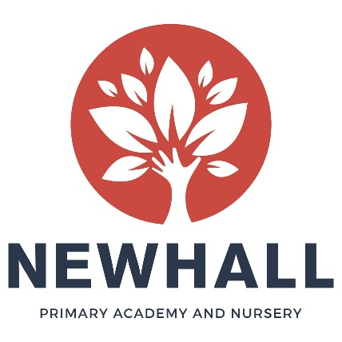
Class Teacher and English Subject Leader

Overview
Are you an outstanding Practitioner with an interest in leading English across a school? Do you want to take the next step in your career and move into a leadership position? Have you got drive and vision to set up a year group from scratch? If so, we would love to hear from you! At Newhall Primary Academy we are looking for an experienced Class Teacher and English Subject Lead. We are looking for someone who is up for a challenge and wants to get stuck in with all aspects of our academy life!

Do you want the rare opportunity to be part of our growing Newhall family? If so, we would love to hear from you!

Post Title: | Class Teacher with responsibility for leading English across the school
Contract type: | Permanent
Location: | Newhall Primary Academy and Nursery
Working hours: | Full-time
Start date: | 20th April 2020
Salary: | Main/Upper Pay Scale with TLR 2

About us
Newhall is a brand-new, state of the art academy on the Newhall development in Harlow, with the capacity for 420 children. The Primary Academy currently has 106 children on roll. It will grow year-on-year until it reaches full capacity (60 per year). The Nursery has capacity for 56 children and is open all year round from 7.30am until 6pm. It offers both funded and private day care places.

The Academy and Nursery opened in September 2018 and we are now seeking additional staff to join us and be part of the unique opportunity to build and grow the setting from its infancy. There is no doubt about it, setting up the Academy and Nursery from scratch takes vision, dedication and hard-work, but being part of that exciting and rare journey is exciting and it will be very rewarding to see the Academy and Nursery take shape over the next few years. To see more information about Newhall, please visit our website.

The children at Newhall are enthusiastic, keen to learn and a joy to teach. We are also supported by a growing community, including very supportive and engaged parents and an active Governing Body.

About the role
As one of the early members of staff to be appointed to Newhall Primary Academy and Nursery, you will help shape its future direction. You will work alongside our Senior Leadership Team and other Newhall staff to help create an exciting and vibrant setting, where all children thrive.

Starting in April, you will set up Year Two from scratch, ordering resources and planning aspects of the curriculum. You will also be responsible for putting forward and realising your vision for English across the school, following on from our teaching of Read Write Inc in EYFS and Year One.

You will be based in the main Academy building and you will work in partnership with other Class Teachers. You will be supported by experienced Senior Leaders and be part of the wider Academy and Nursery Team.

There is potential for your role to grow and adapt with the academy over the coming years, with further leadership opportunities as the school grows.

What we’re looking for:
We are looking for an outstanding classroom practitioner to set up and teach Year 2, in the first instance. You will be someone who is highly driven and motivated, has an eye for detail, and can work flexible and creatively.
The successful candidate will have:
- The motivation to achieve the very best for the children in our care and be relentless in the pursuit of excellence
- Proven experience as an effective good and outstanding classroom teacher
- Experience of working with children of different ages within Key Stage One
- Experience and an understanding of the expectations for Key Stage One SATs
- Knowledge, and preferably experience, of teaching in Key Stage Two
- Excellent communication skills and a good sense of humour
- A positive team player and be able to use your own initiative
In return we can offer:
- A firm commitment to you and your professional development
- Friendly, supportive, enthusiastic and hardworking colleagues, staff and Governors
- A growing learning community
- Encouragement to develop new ideas and the opportunity to make a real difference
-Coaching and mentoring from a member of academy’s Senior Leadership Team
-Fantastic trust-wide CPD opportunities
-Vast opportunities for career progression

How to apply
We hope you will take the time to find out more about our new academy and experience our warm welcome. For further information about the role, or to arrange an informal discussion, please contact the school on 01279 215480 or email office@newhallacademy.org.

Completed applications should be sent via e-mail to head@newhallacademy.org by 3rd February 2020.

Short-listed candidates will be invited for interview on Tuesday 11th February 2020. Newhall Primary Academy is committed to safeguarding and promoting the welfare of children, young people and vulnerable adults and expects all staff and volunteers to share this commitment. The successful applicant will be subject to an enhanced DBS check.

