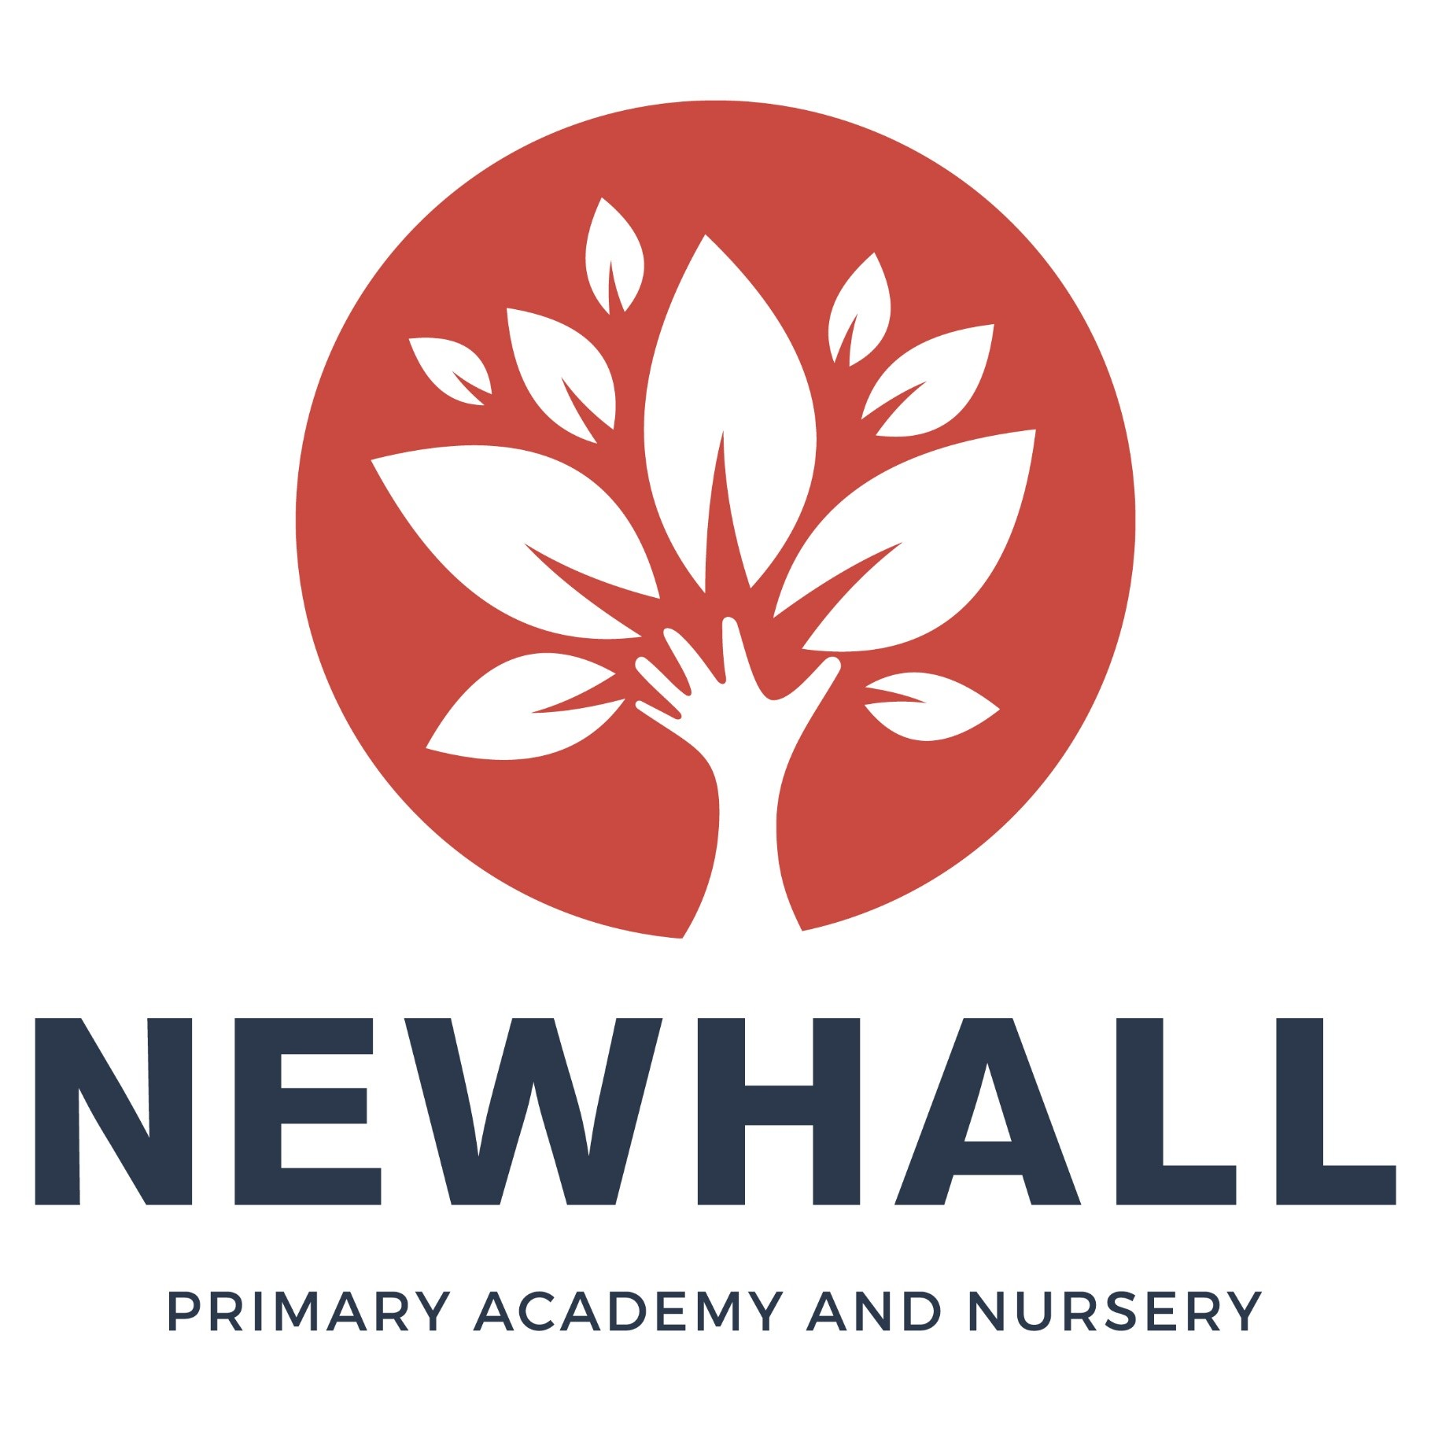

“Aiming high; Reaching higher”

Positive Behaviour Management Policy
(includes COVID-19 expectations)
Linked Policies:
E-Safety Policy
ICT Policy
Safeguarding Policy
Linked Policies:
E-Safety Policy
ICT Policy
Safeguarding Policy
Linked Policies:
E-Safety Policy
Audience: | Parents  School staff  Local Governing Bodies
Approved:
Other related policies: | Anti-Bullying, Equality, Child Protection, SEND, Attendance, Exclusion
Policy owner: | Charmaine Ward
Policy model: | Newhall
Review: | May 2020 (by headteacher)
Version number: | 1

Honesty Respect Responsibility Resilience Aspiration Reflection

Forward
Whilst we are working in exceptional times our first priority, as always, is to keep children safe. Therefore, in accordance with government guidelines, we are implementing a clear approach to social distancing in a number of important areas. Government guidance does not advise that social distancing is essential at all times in school, but it is one of a range of measures that schools are taking to keep children safe. This means:
- sitting children at desks (or play areas for Reception and Nursery) that are far apart where possible
- grouping children into smaller class sizes known as ‘bubbles’
- ensuring everyone queues and eats further apart than normal where possible
- keeping a reasonable distance when in the playground or doing any physical exercise
- visiting the toilet one after the other
- staggering break times
- putting guidelines on the floor in corridors
- avoiding unnecessary staff gatherings

For further details, please see the letter regarding re-opening of Newhall dated 2nd June on our school website.

With regards to the Nursery approach, we understand that social distancing cannot be maintained with the younger children. We endeavour to keep children safe and reduce the risks and therefore some our expectations are:
- staff to maintain social distancing where possible
- grouping children into smaller group sizes known as ‘bubbles’
- encouraging smaller groups in areas of play
- staggering drop-off and collection times
- parents are not to enter the building and only have one adult at drop off and collection times
- staggering meal times
- children not to bring in comforters or toys from home
- staggering staff lunch breaks
- removing soft furnishing and soft toys
- removing resources that cannot be cleaned and that have intricate parts

In line with this approach, we expect pupils as well as adults to follow these expectations which we have incorporated within our ‘school rules’ as explained in this policy.
We recognise that this will be very new and could be challenging in some situations, particularly for younger pupils, where staff will implement social distancing measures as far as they are practicably able, whilst ensuring children are kept safe and well cared for. Similarly, there may be exceptional situations with pupils where social distancing is superseded by our duty of care towards them (such as if a child seriously hurts themselves). In these situations, staff will again take all possible precautions, whilst ensuring that these pupils remain safe and are well cared for.
In all other circumstances, the expectation for social distancing and safe behaviour is now an important part of our behaviour policy. This is intended to ensure that pupils can learn and thrive in a positive, orderly and safe environment.
This policy should typically be applied proportionately for younger pupils to encourage positive and safe behaviour rather than to apply sanctions for accidental lapses. For some pupils, there may be situations where they are deliberately breaching expectations for social distancing and safe behaviour and it is important that staff respond to this consistently.
We recognise that to begin with these expectations will be very unfamiliar and so accidental or momentary lapses of social distancing will be dealt with as such. Pupils will be reminded of the expectation and expected to amend their behaviour immediately.
However, if there are instances where pupils deliberately and repeatedly break this rule then this will be considered a clear breach of the behaviour policy. This will be dealt with seriously and in line with any other breach of the behaviour policy and in accordance with the approaches outlined in full within this policy.

Introduction

At Newhall we have the very highest expectations of behaviour. We have a consistent set of core principles and rules based on the school core values of Honesty, Respect, Responsibility, Resilience, Aspiration and Reflection. Children work towards achieving the highest standard each day both individually and as part of a team.
Everyone at Newhall has a part to play in the promotion of high standards of behaviour. It is important that there is a clear code of conduct reinforced by a balanced combination of rewards and consequences within a secure and positive environment, whilst at the same time promoting an understanding that appropriate behaviour is the responsibility of individuals.

The academy firmly believes in the power of intrinsic motivation in children, and uses this as the main approach to pupil reward. Rather than extrinsically rewarding children, children are taught from the youngest age that adopting the correct learning behaviour is paramount for themselves.

We will, always, challenge any form of discrimination including racist or sexist behaviour, and all forms of bullying. The whole school community, children, staff, governors, parents and volunteers should be aware of and actively involved in implementing our Behaviour Policy.

Vision
Children at Newhall will feel safe, valued and develop a love of learning.
This will be achieved by:
- Always being truthful, fair and inclusive.
- Respecting, listening to, valuing and recognising the uniqueness and achievement of every member of our academy family
- Providing outstanding learning and teaching which enables all students, regardless of gender, race, background or ability, to excel academically, emotionally, physically, socially, morally, spiritually and culturally.
- Equipping children with the resilience and perseverance to become creative and independent thinkers and to become learners for life within an ever-changing world.
- Raising the aspirations of everyone within our academy community so everyone strives for personal excellence in everything they do
- Developing learning activities which stimulate positive models of enquiry, reflection, challenge and innovation.

Core Values

Honesty

Respect

Responsibility

Resilience

Aspiration

Reflection

Policy Statement
At Newhall we believe our school is a community and that it is vitally important that everyone is safe and happy within it. We aim to provide an environment in which our children are secure and confident, irrespective of race, gender, disability and religion, with equal opportunities for all. This advice will be kept under review and updated as necessary.
Aims
The aims of this policy are to:
• Create a calm, purposeful, safe and happy learning environment.
• Create a consistent approach to behaviour management throughout the school, celebrating and praising acceptable behaviour and enforcing firm boundaries for unacceptable behaviour.
• Foster positive, respectful and caring attitudes towards everyone, where achievements at all levels are acknowledged and valued.
• Encourage each child to take responsibility for their own behaviour, leading to increased independence and self-discipline.
• Work in partnership with parents in dealing with any behavioural issues.

Responsibilities:
Senior Leaderships should:

• Report regularly to the Local Governing Board and Trust, providing an overview of behaviour at the school.
• Manage the reporting of incidents related to behaviour within school and analyse relevant data
• Implement strategies to improve and maintain positive behaviour within school and provide support for staff

All staff should:
• Model the school values to pupils and each other, treating all members of the school community with respect
• Follow the school systems and polices consistently.
• Focus on good behaviour and positive reinforcement to raise self- esteem, acknowledging and giving praise for good behaviour and achievements.
• Create a positive, purposeful and safe working atmosphere in the classroom, ensuring that each child is appropriately challenged with their learning.
• Work in partnership with parents in dealing with any behavioural issue.
• Work closely with Senior Leadership and outside agencies, implementing advice and strategies in dealing with a child with behavioural difficulties.

Parents should:
• Ensure that if their child attends school, arrives punctually and in appropriate uniform, notifying the school whether their child will be in attendance the following week.
• Support the school’s policy and systems to promote high standards of behaviour at school and at home.
• Model the school values to all members of the community.

Pupils should:
• Demonstrate the school values.
• Follow class and school code of conduct.
• Strive to manage their own behaviour, making appropriate choices. which allow children around them to learn in a calm, safe environment.

Newhall Academy Positive Behaviour Management Strategy
At Newhall Primary Academy, we have a positive behaviour system that is rooted in our school values; honesty, respect, responsibility, resilience, aspiration and reflection. The language of these values informs the daily dialogue between pupils and staff. The pupils love our rewards system and respect the fairness and need for sanctions. They understand that learning in school is of the upmost importance and that good behaviour helps everyone learn.
Behaviour Zones
At the beginning of each new school year each class agrees, with the support and guidance of the class teacher, a class code of conduct which links to each of our school values. During these unprecedented times, rules around social distancing will be included within the school rules.
By agreeing a code of conduct with the class, the pupils are given ownership of it and it becomes more meaningful to them. The code of conduct is then displayed in the classroom along with ‘Behaviour Zones’. The Behaviour Zones are: Gold, Silver, Green, Yellow, Red. Each child has their photograph or name displayed on the board. At the beginning of everyday, children start in the ‘Green Zone’. The class teacher and pupils refer to it as necessary. At every opportunity, responsibility for behaviour can be given to the child. Adults will move the children’s names/photographs on the zones. At the beginning of each term, the code of conduct is reviewed by the class.

House System
Children are grouped into four House Teams. Every child and member of staff is given one of these four Houses to support. Each child is placed in a House on entry to school in Reception and remains a member of this team throughout their time at the school. Siblings are placed in the same House team.
Houses are named after the four elements:
- Fire – Represented by a dragon
- Earth – Represented by a lion
- Air – Represented by an owl
- Water – Represented by a whale

Each half-term there will be a minimum of one House activity or competition, so that children get the opportunity to work collaboratively and build relationships with members of their house across the school. For example, there may be House Music competitions, sports days or art and design presentations. Due to COVID-19, these House activities may be organised differently or postponed.
Rewards
Children will be rewarded for positive behaviour and achievements in a number of ways:
- Praise – this may be given quietly to the child or in front of a group, class or even whole school
- Moving to Silver or Gold within the ‘Behaviour Zones’ and at the end of the day receiving a Gold or Silver Sticker which an adult will hand to them
- Allocating house points – Pupils receive points on the for modelling one of the six core values. House points are collated weekly and announced in Friday Celebration Assembly which will take place via Zoom call. Half termly rewards are given to the house with the highest number of points. At the end of the year, the winning house will be awarded their ribbons on the House Cup. This system aims to encourage a real sense of pride and achievement for the children. It fosters community spirit and gives the children an opportunity to contribute to something bigger, which involves children from all year groups.
- Certificates – Star of the week, Other recognition certificates – given virtually via Tapestry
- Positive phone calls home to parents may be given
- SLT praise and recognition on Twitter/Website
- Headteacher’s Cup – a message will be sent to parents via email and the cup will be displayed in that child’s classroom for the week.
Sanctions and Consequences
Children who demonstrate behaviour which creates a barrier to learning and is contrary to our values is managed by our sanctions system.
1) A positive ‘We Statement’ is first used to remind children of expectations and values. E.g. “(Name of pupil), we take turns to talk and listen to each other at Newhall, thank you.”
2) Verbal warnings are initially given for negative behaviour, including deliberately breaching social distancing rules, and children are invited to engage with learning appropriately.
3) Moving to ‘Yellow’ on the Zones Board means behaviour has not improved, they may be repeatedly, deliberately, breaching social distancing (despite instruction otherwise). Children are reminded of the behaviour that they need to demonstrate in order to move back to ‘Green’ on the Zones board.
4) If negative behaviour (or continued breaching of social distancing with/without intent to threaten or intimidate other pupils) still continues, the child will be moved to ‘Red’ on the Zones Board which results in a 5-minute time out within the classroom. Children are asked to reflect on their choices and always warmly invited back into the learning if they show a change in attitude.
5) A red card requires involvement from the Senior Leadership Team and parents if behaviour continues or is of a more serious nature. If the pupil is unable to improve their behaviour and participate in a safe and courteous way, then they will be asked to leave the school premises for the remainder of the day.

If problems persist, or for more serious incidents including those that involve bullying or abusive behaviour, the Senior Leadership will go through the following stages of intervention:
1) Fixed term internal exclusion
2) Fixed term external exclusion followed by a reintegration ‘Back to school meeting’ with the child and parents/carers.
3) Pastoral Support Plan meeting- multi agency meeting
4) Positive Referral
If there is no improvement and other children are being put at risk on a daily basis:
5) Permanent exclusion.

Strategies to Support Inclusion

We have a range of support mechanisms to help the inclusion of pupils with emotional/behavioural difficulties and enable their access to the National Curriculum and wider school life.
These strategies are over and above the strategies that are used for the majority of pupils and include:
• Individual programmes of rewards and sanctions which are in addition to our whole school system
• One to one sessions with LSA where possible within the child’s bubble
• Social skills groups within children’s ‘bubble’
• Transition support for children in Year 6 before moving to secondary school
• Referral to outside agencies

Other services and strategies;
• Regular meetings with parents, via telephone during COVID-19
• Individual Behaviour Contracts
• Circle Time
• Children and Family Request Referral
• Anger management strategies
• Social Skills Group within children’s ‘bubble’
• 1:1 session with LSA where possible within the child’s bubble
• SEND referral – One Plan formulated and strategies to support
• Referral to Primary Behaviour Support Team
• Educational Psychologist referral
• Pastoral Support Plan – an improvement plan to support children at risk of exclusion
• Referral to EWHMS (Emotional Wellbeing and Mental Health Service)

Playtime and Lunchtime
At playtime and lunchtime, we make sure that there are plenty of engaging activities which promote good levels of social distance whilst also ensuring the children have fun. Staff on duty wear Hi-Viz jackets so children can find them quickly. If a child’s behaviour on the playground is inappropriate, and cannot be managed by the staff on duty, a member of Senior Leadership is sent for. If the child is hurting others or repeatedly, deliberately, breaching social distancing measures (with/without intent to threaten or intimidate other pupils), they will be deemed to be unable to keep themselves and others safe at school and will be asked to go home for the remainder of the day.
Conduct outside the school gates
The following is taken from ‘Behaviour and discipline in schools Advice for headteachers and school staff ‘(DfE - January 2016)
Teachers have the power to discipline pupils for misbehaving outside of the school premises “to such an extent as is reasonable”.
Subject to the behaviour policy, teachers may discipline pupils for: a) misbehaviour when the pupil is:
i. ii. iii. taking part in any school-organised or school-related activity or travelling to or from school or wearing school uniform or
iv. b) i. ii. iii. in some other way identifiable as a pupil at the school.
or misbehaviour at any time, whether or not the conditions above apply, that: could have repercussions for the orderly running of the school or poses a threat to another pupil or member of the public or could adversely affect the reputation of the school.
In all cases of misbehaviour the teacher can only discipline the pupil on school premises or elsewhere when the pupil is under the lawful control of the staff member.
In all of these circumstances the Headteacher should also consider whether it is appropriate to notify the police (or anti-social behaviour coordinator in their local authority) of the actions taken against a pupil. If the behaviour is criminal or poses a serious threat to a member of the public, the police should always be informed. In addition, school staff should consider whether the misbehaviour may be linked to the child suffering, or being likely to suffer, significant harm. In this case the school staff follow safeguarding policy.
Monitoring and review
The Headteacher monitors the effectiveness of this policy on a regular basis. She also reports to the Governing Body on the effectiveness of the policy and, if necessary, makes recommendations for further improvements.
The school keeps detailed records concerning incidents of inappropriate behavior on CPOMs. All staff are responsible for recording incidents that occur during the school day on CPOMs. The Senior Leadership Team analyse this data to identify patterns of behaviour and implement intervention swiftly.
The school council also monitors behaviour and the behaviour systems using pupil voice surveys.
The Headteacher keeps a record of any child who is excluded for a fixed- term or who is permanently excluded. This data is presented in the Headteacher’s Report to the Full Governing Body on a termly basis. The Governing Body will monitor the rate of exclusions noted in the Headteacher’s termly report to ensure that the school policy is administered fairly and consistently.
This policy will be formally reviewed by the Governing Body every year. In the event of new guidance being made available, this review date will be moved forward.
Designated Member of Staff – Mrs. Charmaine Ward

Appendix 1
Behaviour Management in the Nursery
At Nursery, we follow the policy and procedures as stated above. The children set classroom rules and consider safety, care and respect for each other. We keep the rules to a minimum and ensure that these are age and stage appropriate. We regularly involve children in the process of setting rules to encourage cooperation and participation and ensure children gain understanding of the expectations of behaviour relevant to them as a unique child. Classroom rules are displayed and referred to as and when required.
The key to managing behaviour is distraction. Staff are positive role models and use positive reinforcement and distraction as their starting point to promoting positive behaviour. Where children display difficult behaviour, this will be ignored where it is safe to do so. Staff will focus on positive reinforcement for the other children to encourage positive behaviour throughout the classroom.
If a child behaves physically through biting or spitting, a risk assessment will be completed with regards to the child’s behaviour and the outcome of that risk assessment will determine whether the child is safe to be in nursery during the Coronavirus pandemic. We make sure that the child who has been upset is comforted and the adult will confirm that the other child's behaviour is not acceptable, the child will be encouraged to apologise for their actions. We always acknowledge when a child is feeling angry or upset and that it is the behaviour that is not acceptable, not the child. We help children understand their own, and others, emotions through daily activities and routines, which in turn will help children be more sensitive and understanding of others.
Behaviour Zones are used in the Nursery in Bluebell room. Children will agree their classroom rules with their teachers which will then inform the Behaviour Zones. The Behaviour Zones are: Gold, Green, Red. Each child will start their day in the ‘Green Zone’.
When children behave in unacceptable ways:
- We never use or threaten to use physical punishment/corporal punishment such as smacking or shaking
- We never use the word ‘naughty’ or label a child as a ‘naughty child’. We use words such as ‘kind hands’.
- We do not single out children or humiliate them in any way. Where children use unacceptable behaviour they will, wherever possible, be re-directed to alternative activities. Discussions with children will take place as to why their behaviour was not acceptable, respecting their level of understanding and maturity
- Staff will not raise their voices (other than to keep children safe)
- In any case of mis-behaviour, we always make it clear to the child or children in question, that it is the behaviour and not the child that is unwelcome
- We decide how to handle a particular type of behaviour depending on the child’s age, level of development and the circumstances surrounding the behaviour. This may involve asking the child to talk and think about what he/she has done. All staff support children in developing empathy and children will only be asked to apologise if they have developed strong empathy skills and have a good understanding of why saying sorry is appropriate
- We inform parents (via the Care Diary section of Tapestry during COVID-19) if their child’s behaviour is unkind to others or if their child has been upset. In all cases we deal with inappropriate behaviour in nursery at the time. We may ask parents to meet (virtually or via phone call during COVID-19) with staff to discuss their child's behaviour, so that if there are any difficulties we can work together to ensure consistency between their home and the nursery. In some cases, we may request additional advice and support from other professionals.
- We support children in developing non-aggressive strategies to enable them to express their feelings
- We keep confidential records on any inappropriate behaviour that has taken place. We inform parents and ask them to read and sign any incidents concerning their child
- Through partnership with parents and formal observations, we make every effort to identify any behavioural concerns and the causes of that behaviour. If the behaviour is ongoing, the manager will complete risk assessments identifying any potential triggers or warning signs ensuring other children’s and staff’s safety at all times. In these instances, we may remove a child from an area (but within their bubble) until they have calmed down, they will be supervised at all times.
- Where children are not following classroom rules for example walking feet, we tell the children what they can do rather than what they shouldn’t do. For example, if they are running we say “please use your walking feet” or if they had their feet on their chair we say “feet on the floor” to provide positive and clear instructions.
- When children are behaving unacceptably towards others, the staff are to focus on the child that has been hurt to provide them with attention. A firm ‘no’ with the sign ‘no’ should be said to the child that behaved in an unacceptable way. The member of staff is to change their facial expression and tone of voice to reflect that the behavior in unacceptable. The member of staff should then turn their back to the child and focus on the child hurt.
- Where children continue to display unacceptable behavior and strategies are in place and not working, a meeting will be called with the parents. We may also ask parental permission for a referral to the Area SENCO for support and advice.

