Newhall Primary Academy Curriculum Overview – EYFS

 | Autumn 1 | Autumn 2 | Spring 1 | Spring 2 | Summer 1 | Summer 2
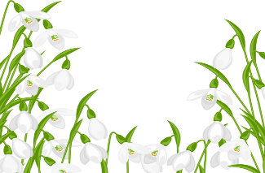  Nursery  (Snowdrop) | All about me | Twinkle, twinkle here we are! | Our furry friends | Food glorious food | Down at the bottom of the garden | Under the canopy
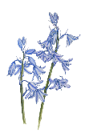  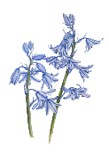  Nursery  Bluebell  Year1 | Marvellous me | Land of rhyme | Superheroes/ People who help us | Sing a rainbow | Roots, shoots and juicy fruits | Ahoy!
Nursery  Bluebell  Year 2 | Me, myself and I | Once upon a nursery rhymes | Dinosaurs | Turrets and Tiaras | Sow and grow | Under the sea
Reception  Willow class  Cherry class | Good to be me | To infinity and beyond | Once upon a Story | Come dine with me | And away we go…. | Save the bees, plant more trees and clean the seas

